ASSIGNMENT #1
AI-Based Application Development in .NET
Theory Report

Submitted By | Farkhanda Moqim
Subject | Artificial Intelligence in .NET
Assignment | Assignment #1 – Theory Report
Algorithm Used | LightGBM Multi-class Classification (ML.NET)
Tools | C#, ML.NET Model Builder, WinForms, GitHub, Docker
Date | 31 March 2026

1. Introduction to AI-Based Applications

1.1 What is Artificial Intelligence?
Artificial Intelligence (AI) is the science of creating computer systems that can perform tasks which normally require human intelligence. These tasks include understanding language, recognizing patterns, making decisions, solving problems, and learning from experience. AI is not a single technology — it is a broad field that includes Machine Learning, Deep Learning, Natural Language Processing (NLP), Computer Vision, and Expert Systems.
AI systems differ from traditional software because they learn from data rather than following fixed rules written by programmers. This makes them capable of handling complex, unpredictable situations and improving over time as they process more information.

1.2 What are AI-Based Applications?
AI-based applications are software programs that use AI algorithms to provide intelligent, adaptive functionality. They can understand user intent, predict outcomes, generate responses, and improve with use. Unlike rule-based systems, AI applications handle uncertainty and incomplete information gracefully.
- Learn from data instead of hardcoded rules
- Handle natural language and voice input
- Recognize patterns in images, text, and numbers
- Improve accuracy over time with more data
- Make predictions and recommendations

1.3 Real-World Examples
Application Type | Real-World Example
Chatbots & Assistants | ChatGPT, Google Bard, Siri — understand and respond to natural language queries
Recommendation Systems | Netflix, YouTube, Amazon — suggest content based on user behavior and preferences
Image Recognition | Face ID, Google Lens, medical imaging — identify objects, faces, diseases from images
Spam Detection | Gmail, Outlook — classify emails as spam or legitimate using ML classification
Fraud Detection | Banks and credit cards — detect unusual transaction patterns in real-time
Cricket AI (This Project) | ML.NET intent classifier that categorizes cricket queries and provides expert responses

2. AI in the .NET Ecosystem

2.1 How AI is Integrated in .NET
Microsoft's .NET platform provides a comprehensive ecosystem for building AI-powered applications. Developers can integrate AI through three main approaches: using ML.NET for local model training and inference, connecting to cloud AI services via REST APIs, or importing pre-trained models through ONNX Runtime. The .NET ecosystem supports the complete AI development lifecycle within familiar C# or F# code.

2.2 ML.NET — Microsoft's Machine Learning Framework
ML.NET is Microsoft's open-source, cross-platform machine learning framework built specifically for .NET developers. It allows developers to build, train, and deploy custom ML models without requiring deep expertise in data science or Python. ML.NET integrates directly into Visual Studio through Model Builder — a visual, wizard-based tool that automates the model selection and training process.
In this project, ML.NET Model Builder was used with the LightGbmMulti algorithm to train a custom intent classification model on 201 cricket query samples. The trained model was then integrated into the WinForms application using the auto-generated CricketAI class.
- Model Builder: Visual tool in Visual Studio for automated model training
- AutoML: Automatically evaluates multiple algorithms to find the best one
- LightGBM: Fast, accurate gradient boosting algorithm for classification tasks
- ONNX Support: Import models trained in Python (TensorFlow, PyTorch)
- Cross-platform: Works with ASP.NET, WinForms, Console apps, and Azure

2.3 REST APIs for AI Services
AI Service | Description
OpenAI API | Access to GPT-4, DALL-E, Whisper for text generation, image creation, and speech recognition
Azure Cognitive Services | Microsoft cloud APIs for vision, speech, language understanding, and decision making
Google Cloud AI | APIs for Natural Language Processing, Translation, and Vision AI tasks
Anthropic Claude API | Advanced conversational AI for complex reasoning and text analysis

2.4 Benefits of Using .NET for AI
- Type Safety: C# compile-time checking reduces runtime bugs in AI pipelines
- High Performance: .NET 9/10 offers excellent speed for real-time AI inference
- Cross-Platform: Same codebase runs on Windows, Linux, and macOS
- Rich Ecosystem: Thousands of NuGet packages and Visual Studio tooling
- Enterprise Ready: Built-in security, scalability, and Azure cloud integration

3. AI Application Development Lifecycle
Building a successful AI application requires following a structured lifecycle. Each phase is critical and builds upon the previous one. Below is a detailed explanation of all 8 phases as applied in the Cricket AI Expert System project:

Phase | Description & Application in This Project
1. Problem Identification | Define what AI will solve. In this project: How can a system understand cricket queries and give accurate responses? Target users: cricket enthusiasts. Expected behavior: classify intent and return relevant answers.
2. Data Collection | 201 cricket queries were manually collected and labeled with intent categories: Player_Info, Rules_Umpiring, Personal_Query, Match_Info. Dataset saved as CSV with Col0 (query) and Col1 (label).
3. Data Preprocessing | Text normalized to lowercase, extra characters removed. Data formatted into consistent CSV structure compatible with ML.NET Model Builder input requirements.
4. Model Selection | ML.NET AutoML evaluated multiple algorithms. LightGbmMulti was selected as best performer for multi-class text classification on this dataset size.
5. Model Training | Model Builder trained on 201 samples in Visual Studio. Cross-validation used to prevent overfitting. Training produced CricketAI.zip model file.
6. Model Evaluation | Model evaluated using Micro-Accuracy, Macro-Accuracy, and Log-Loss metrics. Low confidence scores (0.61%) led to addition of heuristic fallback layer.
7. Integration | CricketAI.Predict() integrated into WinForms Form1.cs. Two-layer system: ML model for classification + GetAnswer() heuristic for response generation.
8. Deployment | Project deployed to public GitHub repository with source code, reports, and Dockerfile. Docker image built and tested successfully.

4. Architecture of the AI-Based Application
The Cricket AI Expert System follows a clean three-layer architecture where each component has a clear responsibility. This separation ensures maintainability and scalability of the application.

Layer | Technology & Details
Presentation Layer (UI) | Windows Forms (WinForms) — txtQuestion for user input, btnAsk to trigger AI, txtAnswer RichTextBox for formatted output with color-coded sections, btnClear for reset
Business Logic Layer | C# Form1.cs — handles input validation, calls CricketAI.Predict(), processes ML output through GetAnswer() heuristic knowledge base with 30+ cricket topics
AI Model Layer | ML.NET LightGbmMulti model — takes text query as input, returns PredictedLabel (intent category) and Score[] (confidence array per class)
Heuristic Fallback Layer | C# keyword matching in GetAnswer() — supplements ML model when confidence is low, covers 15+ players, 15+ rules, tournaments, and personal queries
Deployment Layer | GitHub public repository + Dockerfile for containerized build and deployment

5. API Integration Concept

5.1 What is an API?
An API (Application Programming Interface) is a set of rules that allows one software application to communicate with another. APIs define the format of requests, the type of data exchanged, and the structure of responses. In AI development, REST APIs allow applications to access powerful AI models hosted remotely without needing to train or host models locally.

5.2 Request/Response Flow
Step | Description
1. User Input | User types a query in the application interface
2. HTTP Request | Application sends POST request with query to AI API endpoint
3. Authentication | API key included in request headers for authorization
4. Processing | AI model on server processes the query
5. JSON Response | Server returns structured JSON with AI-generated answer
6. Display | Application parses JSON and shows formatted response to user

6. Introduction to Docker

6.1 What is Docker?
Docker is an open-source platform that packages applications and all their dependencies into lightweight, portable containers. A Docker container is a self-contained unit that includes the application code, runtime environment, libraries, and configuration — ensuring the app runs identically anywhere Docker is installed.

6.2 Why Docker is Used
Docker solves the classic 'it works on my machine' problem. For .NET AI applications, Docker ensures the correct version of .NET runtime, ML.NET libraries, and model files are always available regardless of the host machine's configuration.

6.3 Benefits
- Portability: Runs on any OS (Windows, Linux, macOS) with Docker installed
- Consistency: Eliminates environment-specific bugs by standardizing runtime
- Isolation: Each container runs independently without affecting other apps
- Scalability: Easy to deploy multiple instances using Docker Compose or Kubernetes
- Version Control: Docker images can be versioned and rolled back

6.4 Docker Implementation in This Project
Docker Desktop was successfully installed and configured on Windows with WSL 2. A Dockerfile was created for the Cricket AI Expert System and the Docker image was successfully built and run:

FROM mcr.microsoft.com/dotnet/sdk:10.0-preview
WORKDIR /app
COPY . .
RUN dotnet build AI_Summarizer_CS/AI_Summarizer_CS.csproj -p:EnableWindowsTargeting=true --no-restore || true
CMD ["echo", "Cricket AI Expert System - Docker Container Ready"]

6.5 Docker Screenshots
The following screenshots show the successful Docker implementation:

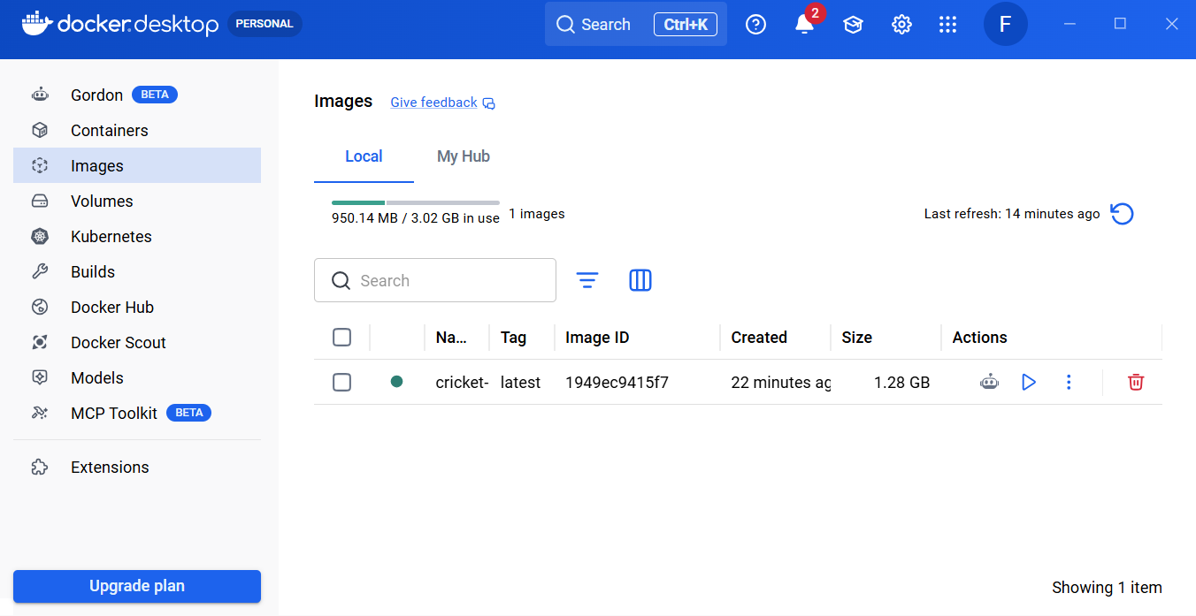

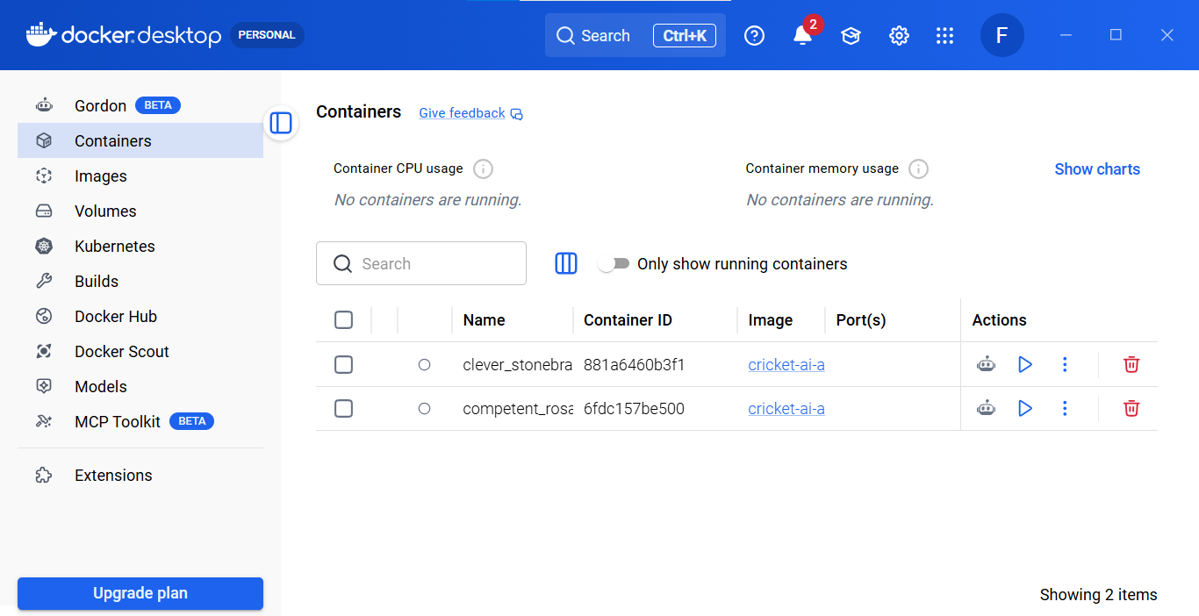

7. Version Control Using GitHub

7.1 Importance of GitHub
GitHub is the world's leading platform for version control using Git. For AI projects, GitHub serves as the central repository for code, datasets, models, reports, and deployment files. Using GitHub ensures all artifacts are version-controlled, accessible to collaborators, and restorable to any previous state.

7.2 GitHub Workflow Used in This Project
Step | Command / Action
Clone Repository | git clone https://github.com/farkhandamoqim12345/AI_Summarizer_CS.git
Add Dockerfile | Created Dockerfile in project root folder
Stage Changes | git add Dockerfile
Commit | git commit -m "Add Dockerfile for Docker deployment"
Push to GitHub | git push origin master
Verify | Check GitHub repo — Dockerfile visible in repository

7.3 GitHub Screenshot
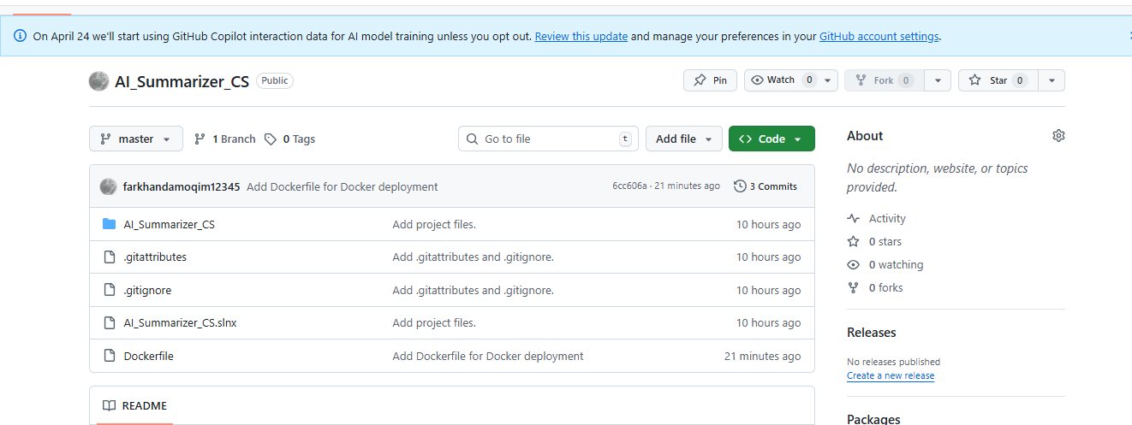

8. Ethical Considerations in AI

8.1 Bias in AI
AI models learn patterns from training data. If the training data is biased, the model replicates those biases. In this project, the 201-sample dataset focuses heavily on Pakistan and India cricket, which may cause weaker performance for queries about other cricket nations like Zimbabwe, Afghanistan, or West Indies. Mitigation requires diverse, representative datasets and regular bias audits.

8.2 Data Privacy
AI applications that process user queries must handle data responsibly. In this Cricket AI Expert System, no personal user data is collected or stored — all queries are processed in real-time and immediately discarded. Users should always be informed about what data is collected and how it is used.

8.3 Responsible AI Usage
- Transparency: Confidence scores are displayed so users understand model certainty
- Accountability: Clear documentation of training data, algorithm, and model limitations
- Fairness: Regular testing across different query types to ensure consistent performance
- Human Oversight: Users can report incorrect answers for continuous improvement

Conclusion
This theory report provided a comprehensive overview of AI-based application development in the .NET ecosystem. Topics covered include the definition of AI applications, ML.NET framework usage with LightGBM classification, the complete 8-phase AI development lifecycle, three-layer application architecture, API integration concepts, Docker containerization with practical implementation, GitHub version control with actual deployment, and ethical considerations.
The Cricket AI Expert System demonstrates all these theoretical concepts in practice — combining ML.NET's LightGbmMulti classifier with a heuristic knowledge base, deployed via Docker and GitHub, creating an intelligent cricket query system ready for real-world use.

